New Spray Bottle

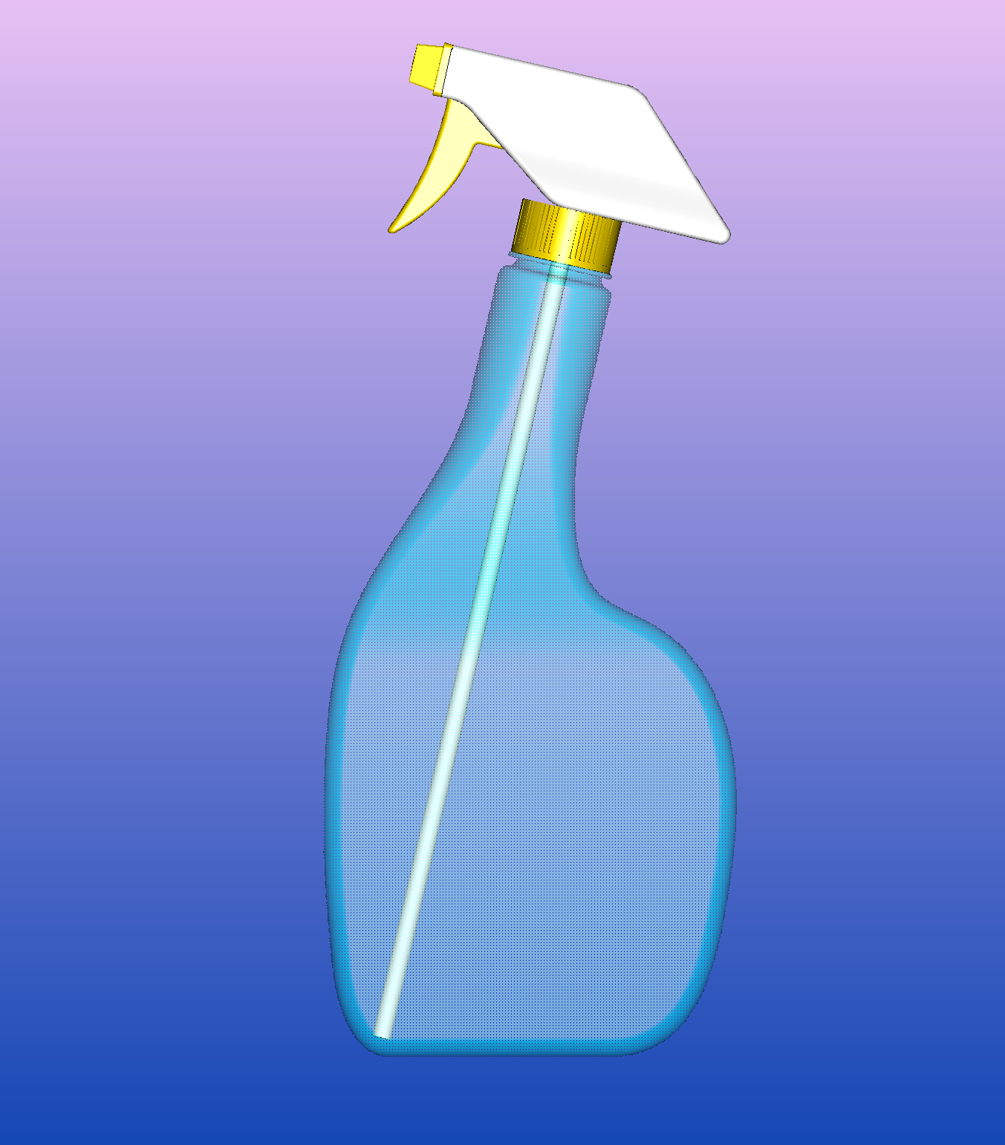

With this new Spray Bottle you can spray out up to the last content of the bottle

This new Dispenser is Patent Pending with the United States Patent and Trademark Office.

Existing Spray-Bottles
Spray-Bottle dispensers for fluids have widespread consumer acceptance and appeal, however, the tilting or inclination of spray-bottles in use and because of the placement of a lower end of the dip-tube are such that before all of the fluid is evacuated from the bottle, prime to the pump is lost and the user of the spray-bottle must remove and perhaps apply or use the remaining fluid in some less convenient or efficacious way. The necessity of undertaking to remove the remaining fluid, which may or may not be substantial in volume, naturally has the effect of reducing the appeal of such dip-tube style dispensers for fluids.

This pictures shows what happens at the end of the dip-tube with the existing spray-bottles:

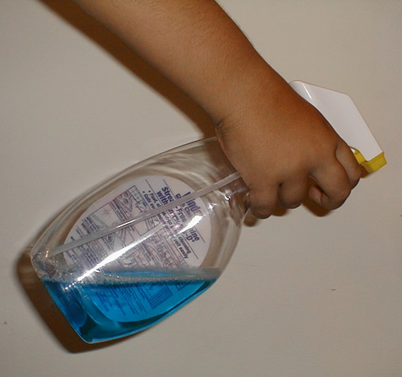

The dip-tube can no longer suck liquid from the bottle. Prime to the dip-tube is lost when the dispenser is inclined having little fluid.

New Style Spray-Bottle
Here is an image of the new style: Prime to the dip-tube is not lost when the dispenser is inclined having little fluid. The neck of this bottle was bent back using hot water. This bent allows the dip-tube of the pump to be oriented to the lower and deeper corner of the liquid.

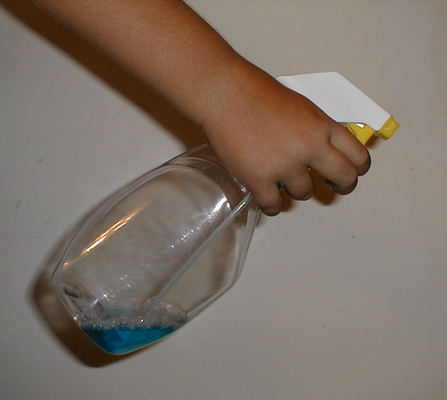

Several advantages of the new bottle are:
To keep the dip-tube submerged in the container's fluid at all times during use of the dispenser to avoid lost of prime.
To enable a more complete withdrawal and efficient use of the fluid within the bottle.
To allow an easy manufacturing of a dispensing container by only modifying the upper part of the bottle by inclining the neck portion or by inclining the fastening portion at the upper end of the bottle's neck.

These two images show the new and the existing spray bottles, as they would stand on a flat surface.
The neck of the new dispenser is inclined in order to direct the dip-tube to the side of the lower bottom.

New Bottle Existing Problem Bottle
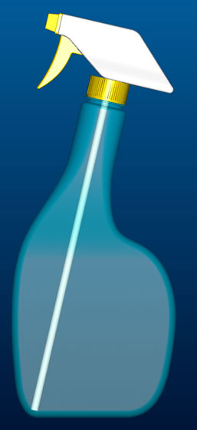

No changes are necessary to the pumps that are already in the market when changing to the new bottle.

Image of new style: The dip-tube sucks all the content of the bottle


Image of existing problem: The dip-tube cannot suck all the fluid out of the bottle.


Summary of the Invention
The present invention addresses the problem of loosing prime to the dip-tube by providing an improved hand held dispenser for fluids which comprises: a container having an upper end which has a neck or fastening opening inclined to the horizon to force the positioning of the dip-tube to the side of the bottom of the container. Dispensing means positioned adjacent to the upper end of the container for dispensing a fluid held in the container and communicated to the dispensing means and a tube for communicating the fluid upward from a lower end of the tube to the dispensing means. The tube is of a sufficient length such that the lower end of the tube is urged toward the side lowermost portion of the bottom to avoid lost of prime when the container is oriented as in use.

This is how the bottle will position itself when hanging vertically from a person hand:

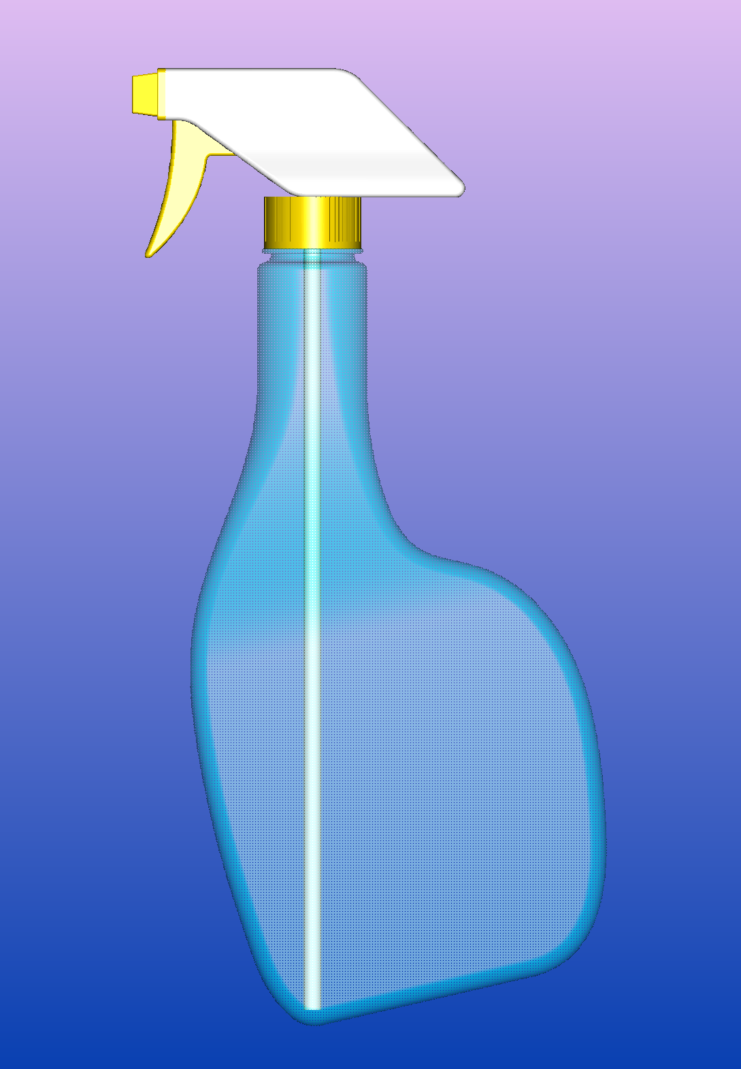

This new bottle is Patent Pending with the United States Patent and Trademark Office and it is available for licensing.

Inventor: Rosa A. Shand
Address:
18771 Still Lake Drive
Jupiter, Florida 33458
Telephone: (561) 741-3122
Email: rashand@bellsouth.net

This Microsoft Word document is available for download at our website www.abigworld.com

